MHA PRESIDENT’S MESSAGE – SPRING 2022

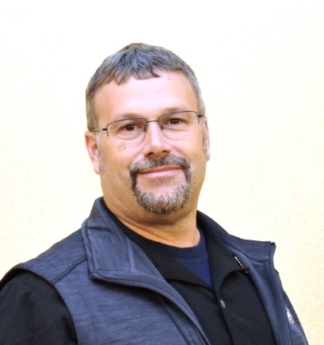

happy Spring,

I hope this letter finds everyone well and ready for some nice spring weather days to enjoy. It is nice to be back to normal with in person meetings, seeing people without masks on. The past two years have seemed like it has been the movie “Groundhog Day”. As I write this message, I realize this is my last President’s Message. Two years seems to have gone by very quickly as president of the MHA. I have been very lucky to have worked with a great board of directors on a lot of important topics / projects during these two years.

I am excited that we have the annual meeting planned for May, the program committee has put together a great program and the MHA Board is busy planning the rest of the years events as scheduled on the calendar. The New England Public Works Expo committee has been working extra hard, and they have a new location for this year. I hope to see you out at our events this year.

We need to continue to work with our elected officials on the importance of the Chapter 90 program and how this helps all Cities and Towns. It is great that Governor Baker has filed legislation for $200M in Chapter 90 funding for FY23 and he has also filed a supplemental budget with an extra $100M for Chapter 90 and an extra $100M in winter road repairs funding, Thank you Governor Baker. We need to get the Legislators to also support and approve this important much needed funding for roads and bridges for this year and send it to the Governor desk to be signed and released.

This year it will be challenging due to inflation, supply chain issues and help shortages with contractors and vendors. This is why we need to show why we need regular increases to keep pace with inflation as we can expect our Chapter 90 funds to not stretch as far this year, but the work we need to accomplish will still be there uncompleted due to funding constraints.

It will always be the time to start thinking about how we can encourage and show our Legislators and Elected officials how important an increase to funding and a multiyear Chapter 90 Bond Bill will be in continuing to stabilize and help our economy. It is important to point out that Chapter 90 gets spent with LOCAL IN-STATE BUSINESSES that employ RESIDENTS / TAXPAYERS. This will be spent repairing the 80 percent of the road miles of infrastructure that the Cities and Towns are tasked to maintain, resulting in improved infrastructure, jobs, and tax revenue all retained in our state. This is the true way to spur our own economy in Massachusetts. We also must stress the importance of a timely release of the funds so that we may bid and award contracts early in the spring, working within the short weather window that we have in Massachusetts to get quality work completed.

We have been working hard over the past year on the mutual aid program with the help of MassDOT GeoDOT Team, Tito from BETA, MEMA, CMAC’s and the Mutual Aid Committee. What this team has done it a short amount of time has been unbelievable, the help from the technical experts to take our ideas and put it into a GIS based platform and have it hosted cannot ever be measured. We now have a platform for our CMAC’s to track requests for aid, track resources being requested / deployed, when it arrived and when it returned back, and to finally close the request out. Over the past year for a few events, we have helped to get resources for we have learned what worked well and where we needed improvements to get to where we are today. Mutual aid will always need to change, grow and evolve, we now have a great foundation and team to continue onward and upward. Please check the MHA website and upcoming meetings for when we roll this out at 100% as we will need everyone to make sure we have current 24/7 contact info for each City and Town for our CMAC data base to make sure we can provide help when requested in a timely manner.

I want to take a moment to thank all the Public Works’ staff in all our Cities and Towns for everything that you do daily and that sometimes goes unrecognized or unappreciated by residents. People are what make public works, without them it doesn’t happen. Thank you to you and your staff for being on the front lines every day and getting the work we do done as what we do is very important to our residents and visitors.

I want everyone to remember the lessons of strength, innovation, resilience and adapting to challenges we never could have imagined over the past two years, this is why we are PUBLIC WORKS STRONG.

Christopher J. Bouchard
President MHA

